**Objectives:**

## Describe the strengths and weaknesses of each topology.

## Identify the appropriate topology for your particular network plan.

## Overview of wireless technology.

1. Get introduced to the 5 topologies

## **Introduction**

Network topology is the arrangement of the elements (links, nodes, etc.) of a communication network. Network topology can be used to define or describe the arrangement of various types of telecommunication networks.

Network topology is the topological structure of a network and may be depicted physically or logically. It is an application of graph theory wherein communicating devices are modeled as nodes and the connections between the devices are modeled as links or lines between the nodes. Physical topology is the placement of the various components of a network, while logical topology illustrates how data flows within a network. Distances between nodes, physical interconnections, transmission rates, or signal types may differ between two different networks, yet their logical topologies may be identical. A network’s physical topology is a particular concern of the physical layer of the OSI model.

Examples of network topologies are found in local area networks (LAN), a common computer network installation. Any given node in the LAN has one or more physical links to other devices in the network; graphically mapping these links results in a geometric shape that can be used to describe the physical topology of the network. A wide variety of physical topologies have been used in LANs, including ring, bus, mesh and star. Conversely, mapping the data flow between the components determines the logical topology of the network. 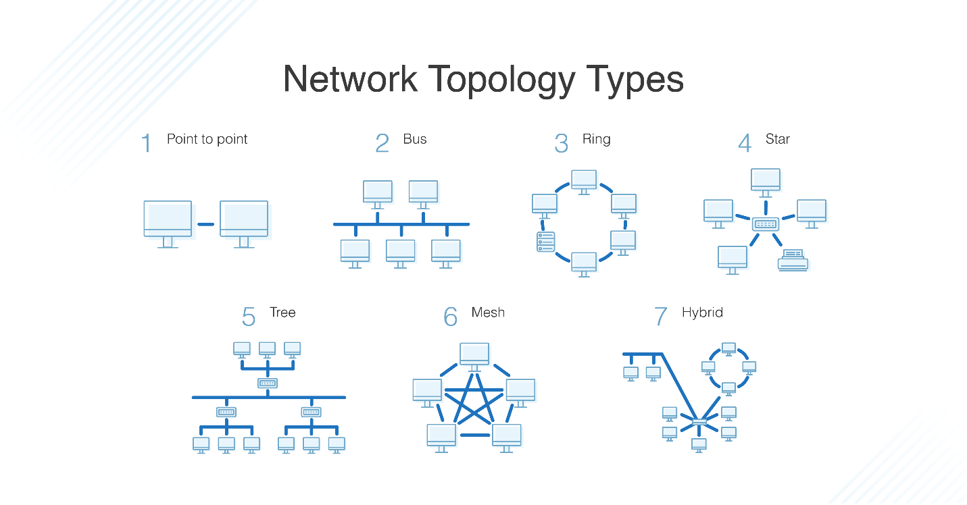

**1. Bus topology**

A topology for a Local Area Network (LAN) in which the nodes (computers or PCs) are

connected to a single cable which called a backbone or segment as shown in figure 1. Which was

the original form of Ethernet network.

Messages sent by any machine are received by all others. It will keep bouncing back and forth

along the cable until in reach the destination address. The destination address will accept the

message while all other machine connected to the cable will reject this message.

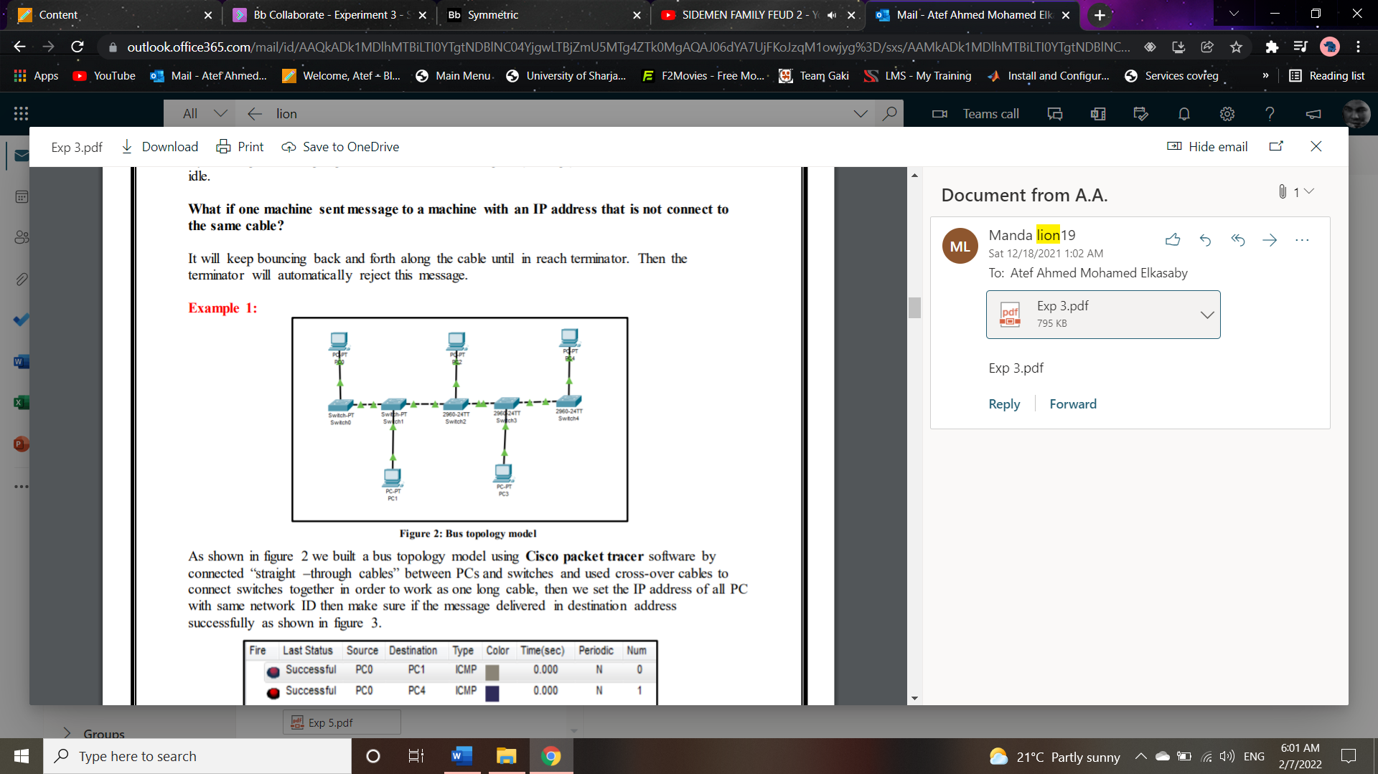

**2. Star topology**

Computers are connected by individual cables to a central unit, usually a hub as in figure 4.

When a computer or other networking component transmits a signal to the network, the signal

travels to the hub. Then, the hub forwards the signal simultaneously to all other components

connected to the hub. Ethernet 10BaseT is a network based on the star topology. Star topology is

the most popular way to connect computers in a workgroup or departmental network.

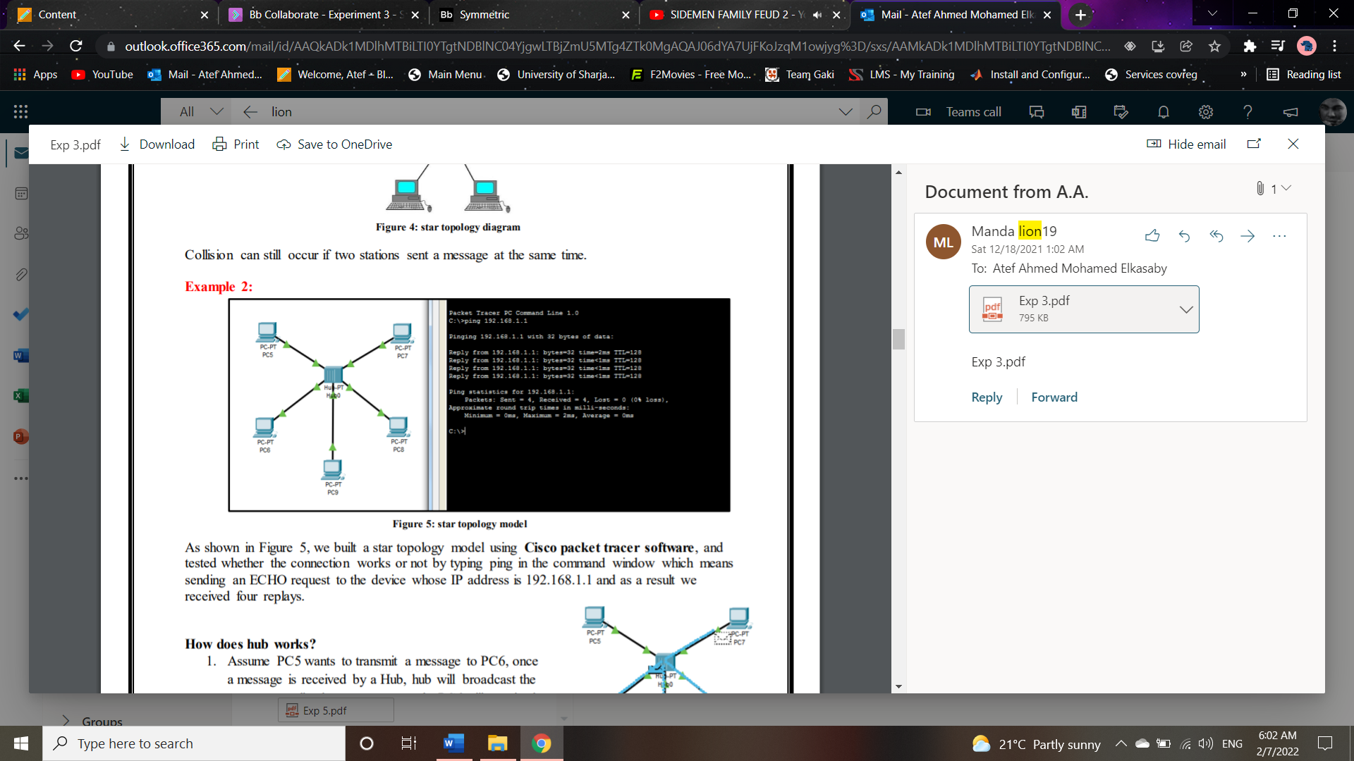

**3. Ring topology**

A ring topology connects the computers along a single path whose ends are joined to form a circle as figure 8. The circle might be logical only but the physical arrangement of the cabling might be similar to star topology, with a hub or concentrator at the center. Each packet is sent around the packet till it reaches the destination.

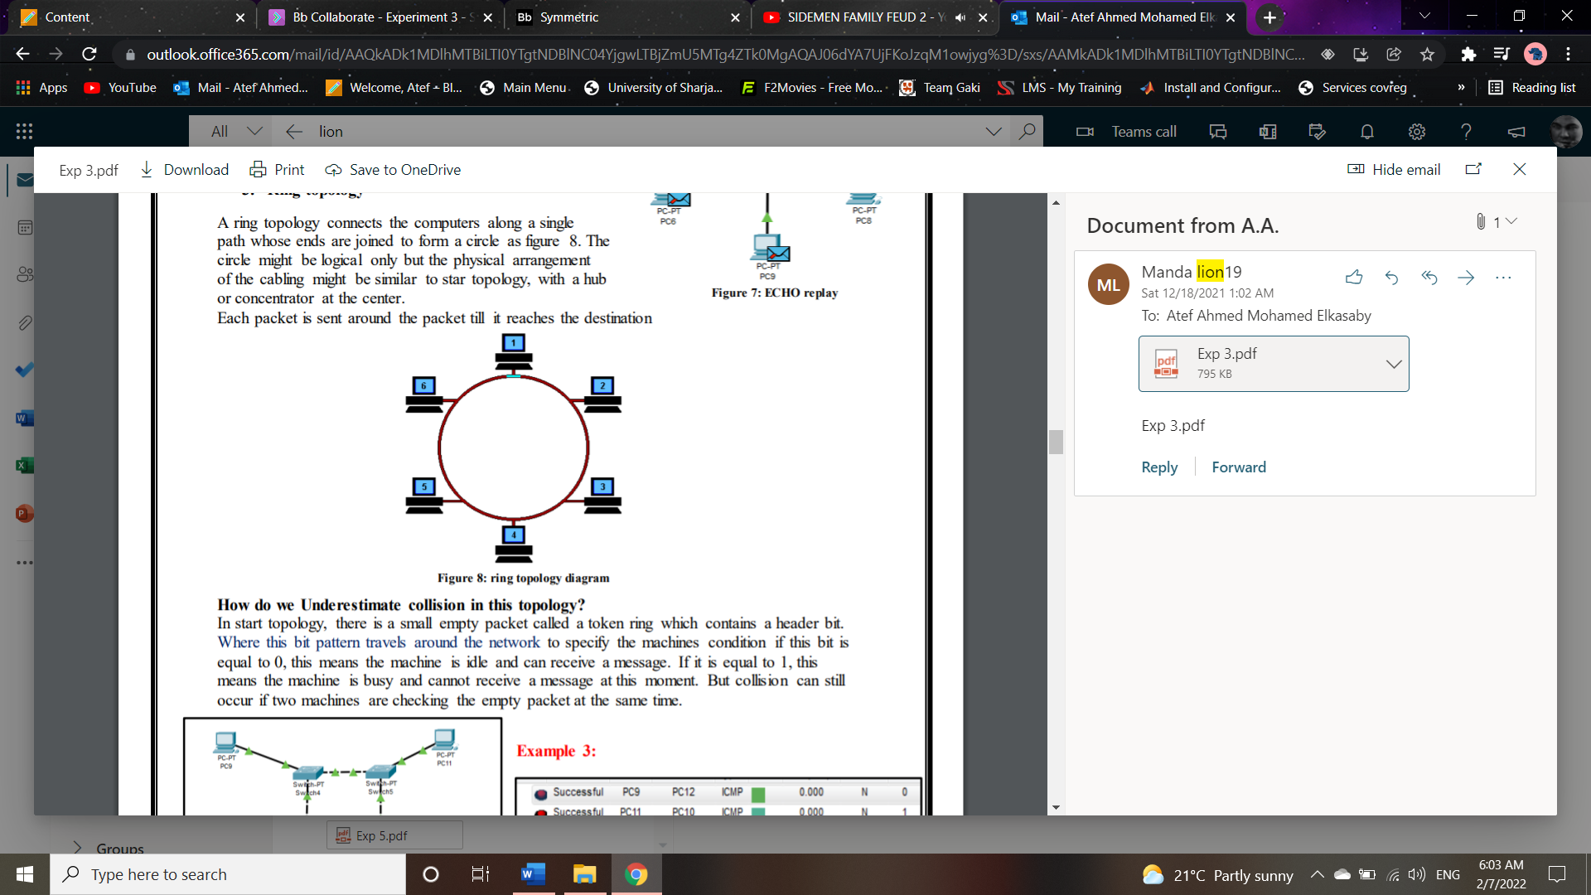

**4. Hybrid topology**

Star- Bus Topologies

The star bus is a combination of the bus and star topologies. In a star-bus topology, several star

topology networks are linked together with linear bus trunks. If one computer goes down, it will

not affect the rest of the network. The other computers can continue to communicate. If a hub

goes down, all computers on that hub are unable to communicate. If a hub is linked to other

hubs, those connections will be broken as well.

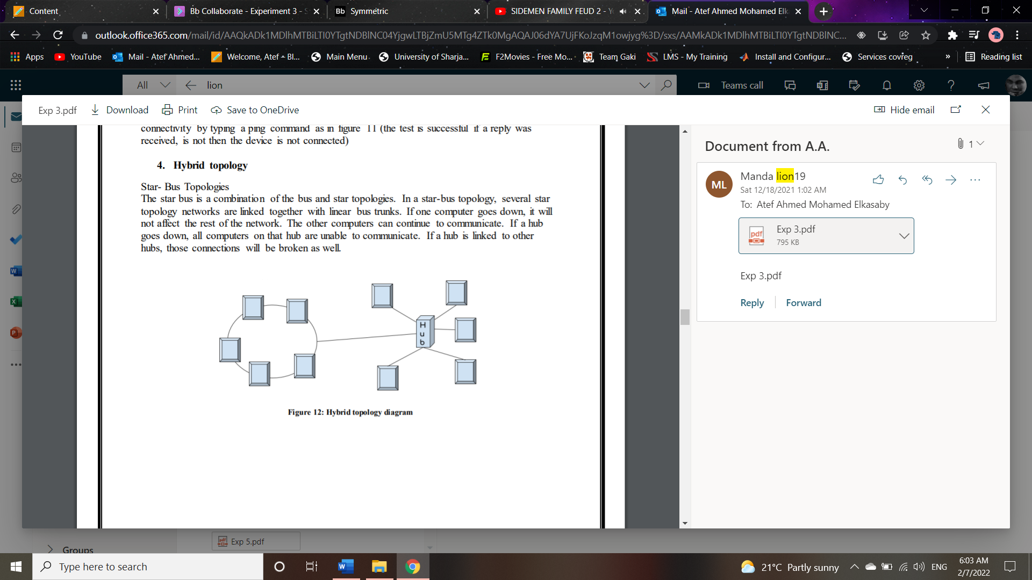

**5. Mesh topology**

A mesh topology is a network setup where each computer and network devices are interconnected with one another. This topology setup allows for most transmissions to be distributed even if one of the connections goes down. It is a topology commonly used for wireless networks.

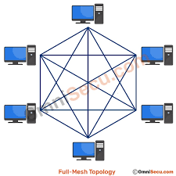

**Advantages of a mesh topology**

* Manages high amounts of traffic, because multiple devices can transmit data simultaneously.
* A failure of one device does not cause a break in the network or transmission of data.
* Adding additional devices does not disrupt data transmission between other devices.

**Disadvantages of a mesh topology**

* The cost to implement is higher than other network topologies, making it a less desirable option.
* Building and maintaining the topology is difficult and time consuming.
* The chance of redundant connections is high, which adds to the high costs and potential for reduced efficiency.

**Part 2: Wireless LANs:**

A technology that enables two or more entities to communicate without network cabling, such us: A wireless Internet service provider (WISP) is an Internet service provider (ISP) that allows subscribers to connect to a server at designated hot spots (access points) using a wireless connection such as Wi-Fi.

**Procedures:**

**Part1 (Wired)**

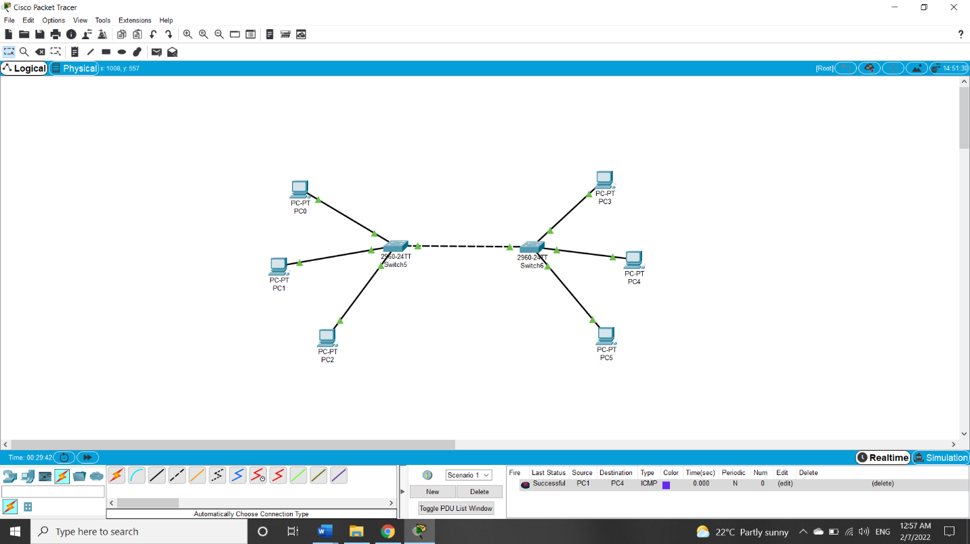Using Packet Tracert Software, build the hybrid star bus as shown in Figure 5. Take screen shot for the main steps. You can choose your own logical IP addresses for your network. Try to use the network applications like ping and tracert to test and analyze.

**Figure 1**

**Figure 1** shows the network of star-bus topology, cross-over for same devices and straight for different ones.

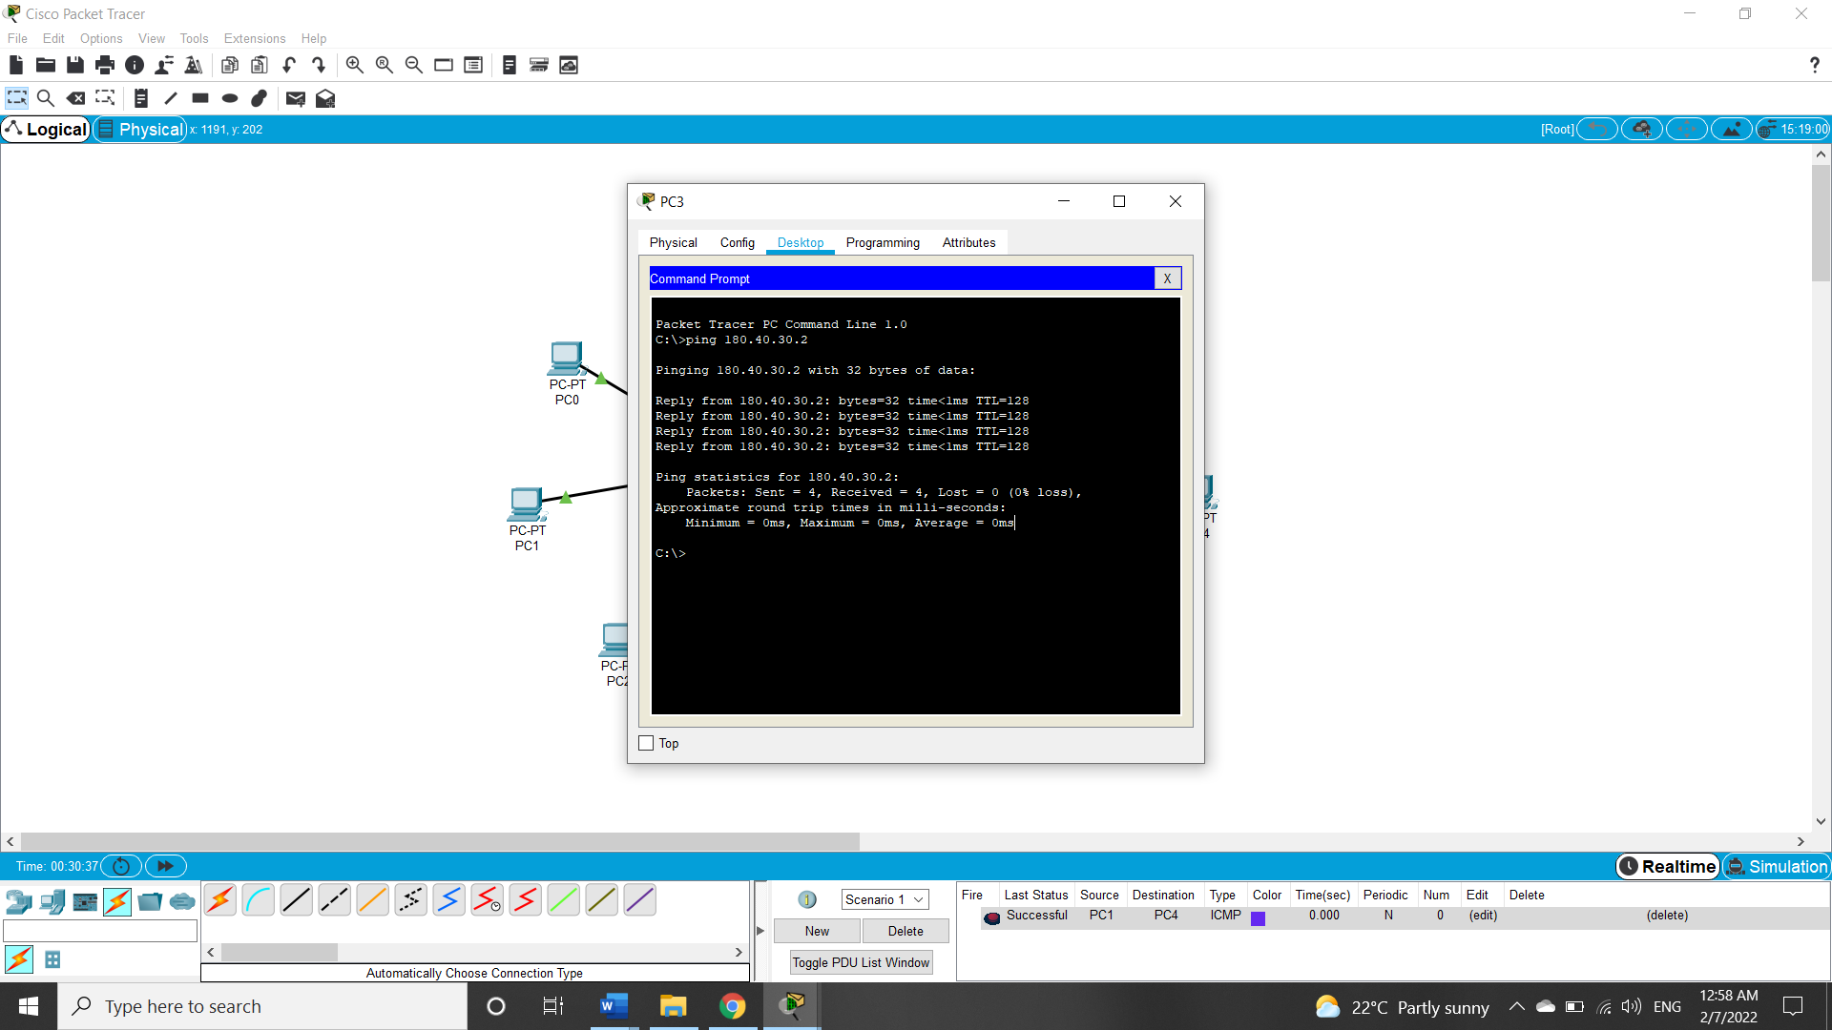

**Figure 2**

**Figure 2** shows the ping command with a device in same switch connection.

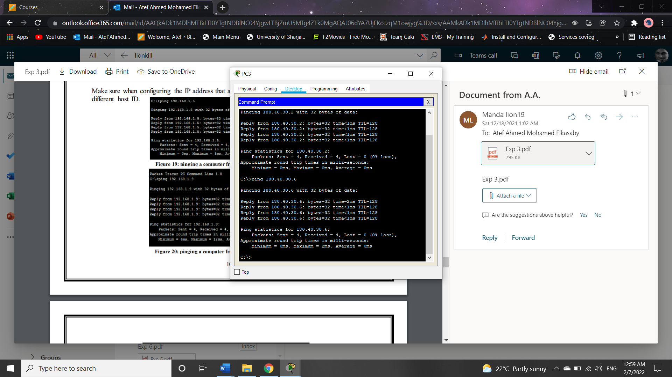

**Figure 3**

**Figure 3** shows ping command to check network connection with a device on different switch connection.

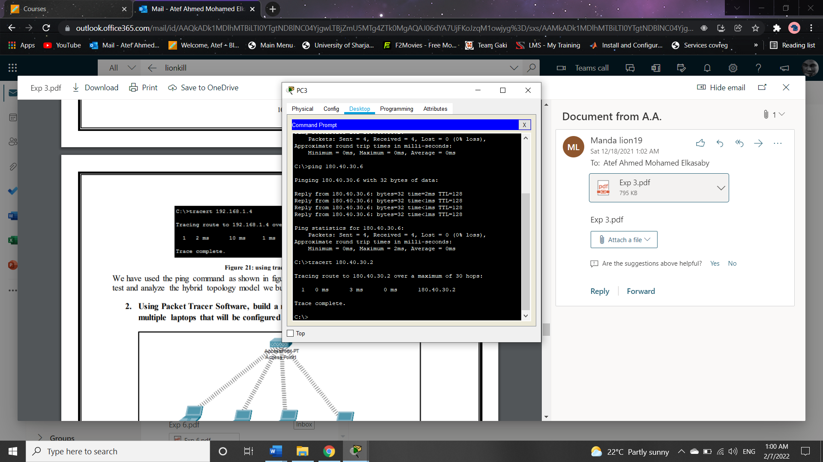

**Figure 4**

**Figure 4** shows the package path between device 1 and 2.

Commands have been used to test our hybrid network connection and it is a successful connection in the network.

**Part2 (Wireless - Static)**

Using Packet Tracert Software, build a network scenario with one access point and multiple laptops that will be configured statistically.

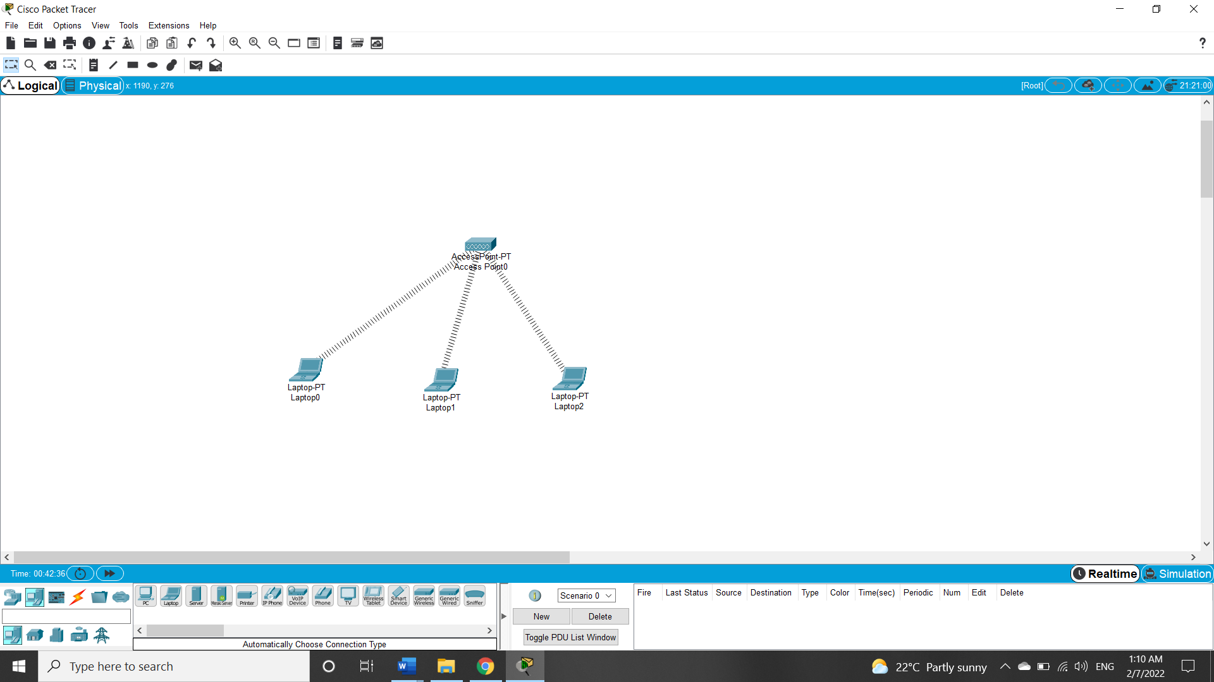

**Figure 5**

**Figure 5** shows our wireless network.

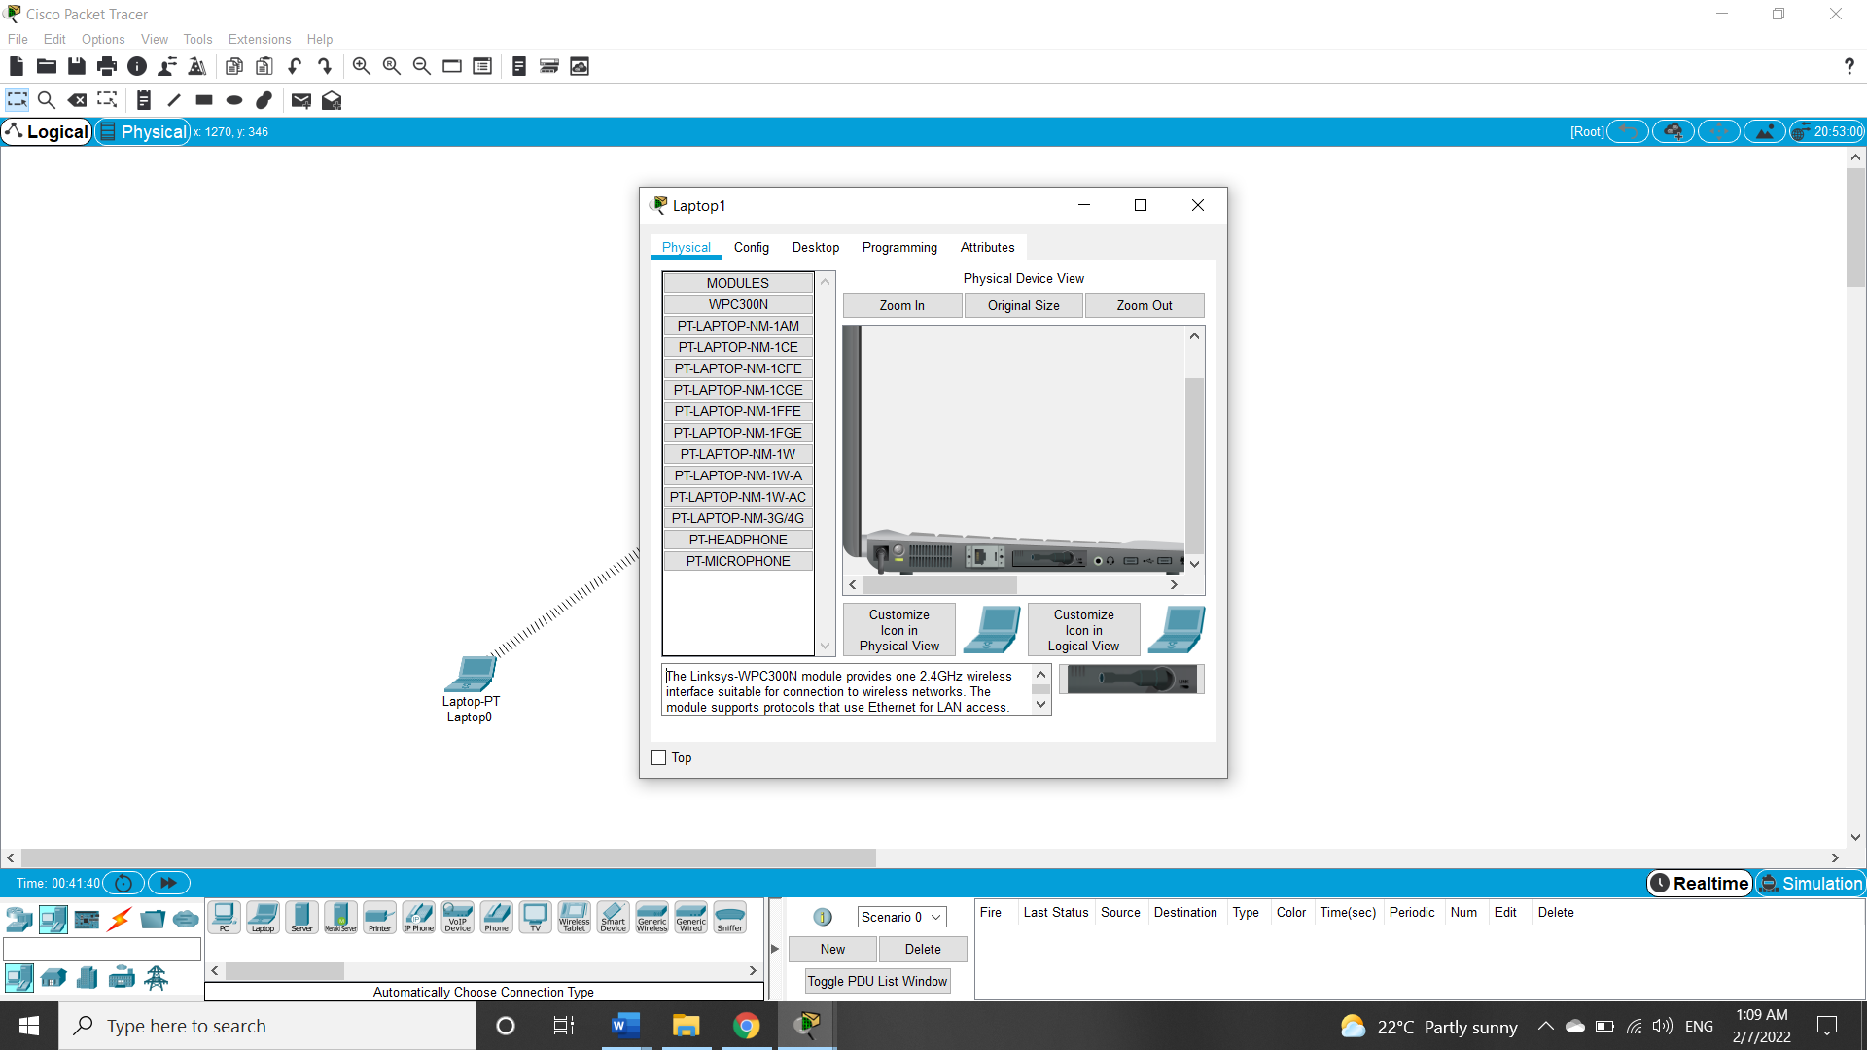

**Figure 6**

**Figure 6** shows our device physical configuration, we have to turn off laptop to change the LAN connection port with wireless one to enable wireless connection.

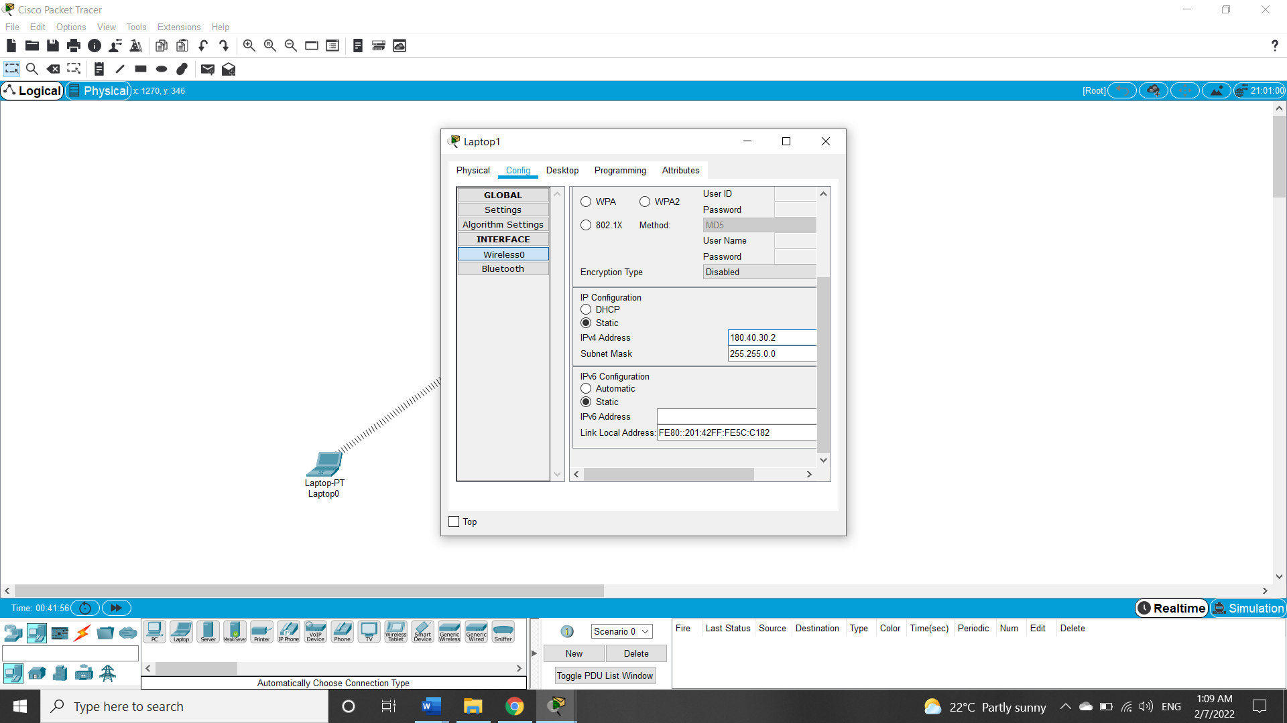

**Figure 7**

**Figure 7** shows the manual static IP address configuration, in static we choose the IP we want our devices in our network to have.

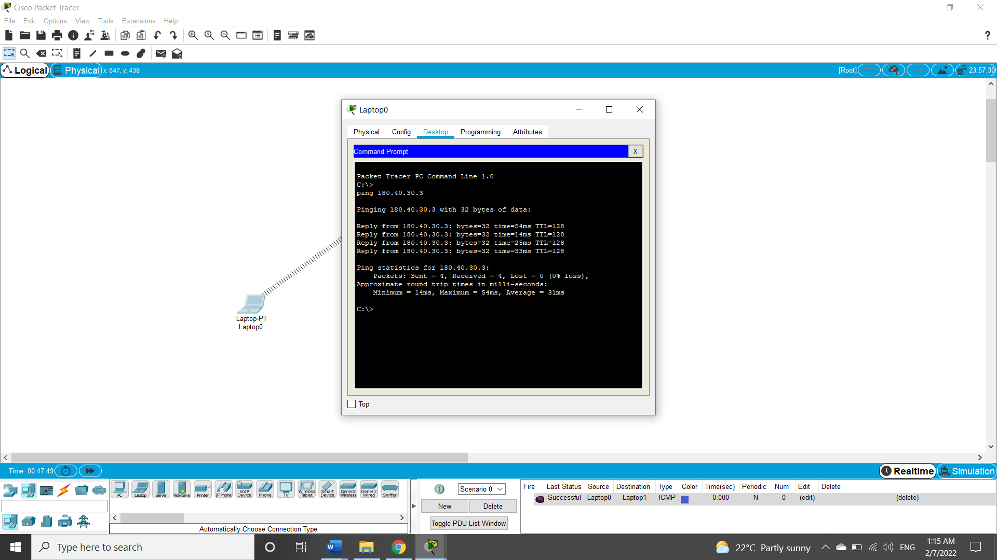

**Figure 8**

**Figure 8** shows that the network connection between two laptops was successful through the ping command.

**Part3 (Wireless - Dynamic)**

Connect your machine to your home access point and show the main steps.

First, we go to control panel, then choose network, adapter settings and then select wireless connection and go through the following steps.

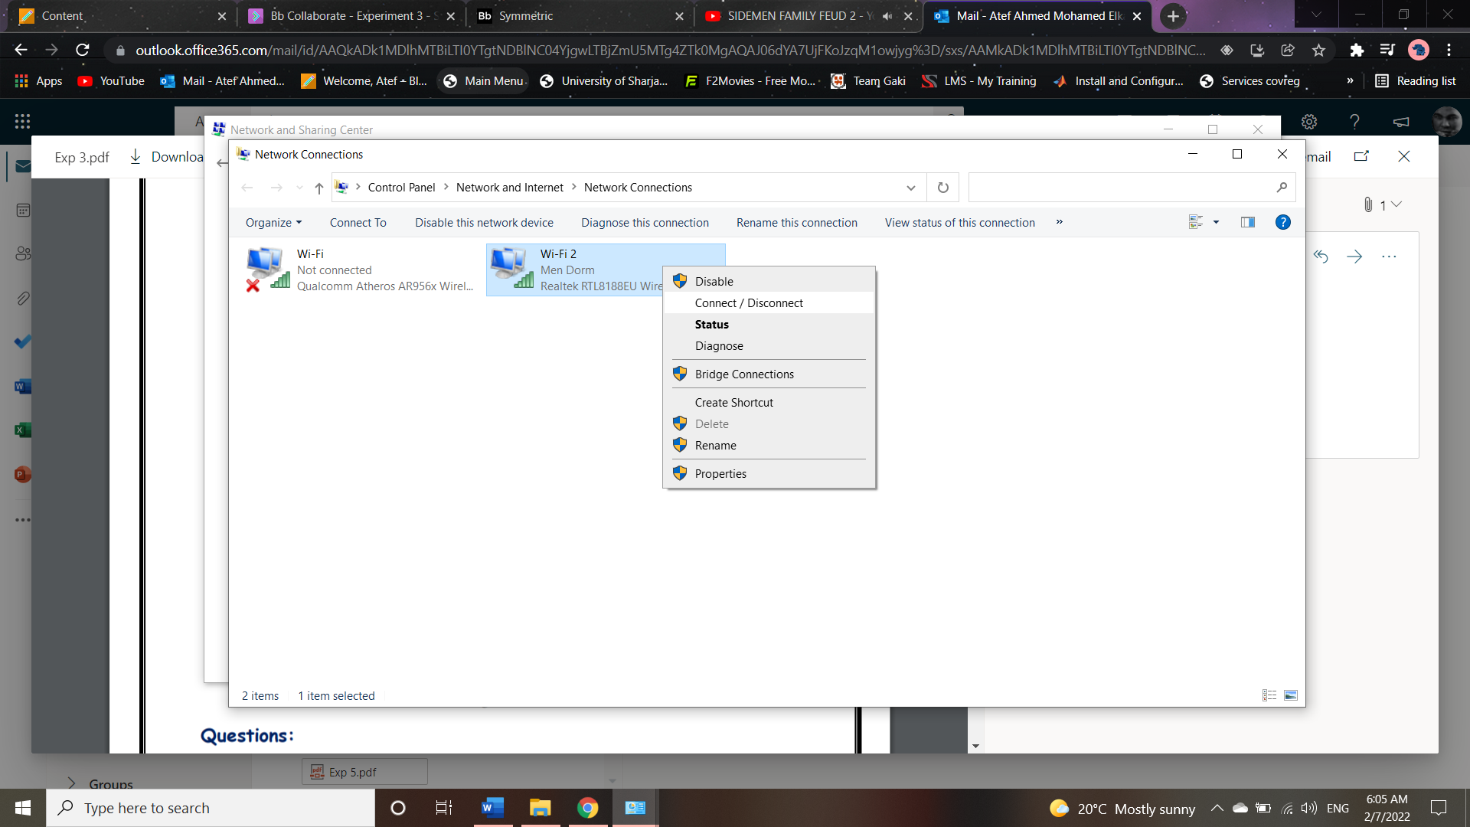

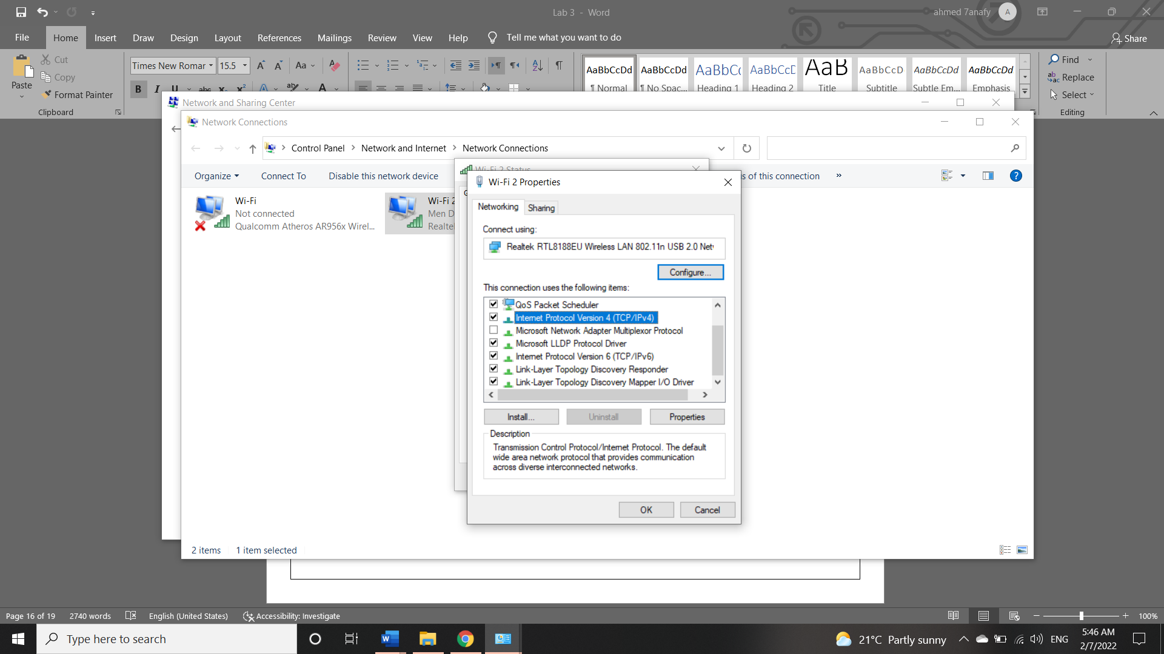

**Figure 9**

**Figure 9** shows the IPv4 protocol is selected from the network properties settings.

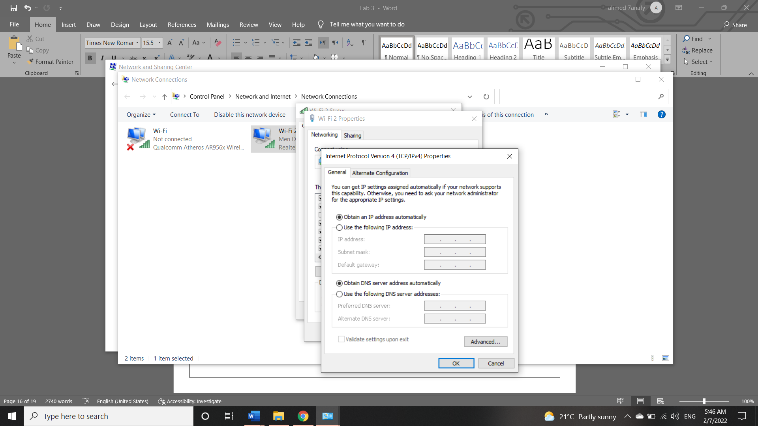

**Figure 10**

**Figure 10** shows the dynamic connection that is set by the internet provider.

**Questions**

1. What are the most important factors that (in addition to the number of networked computers) may affect the performance of a network?

* The delay in time for a packet to be delivered can impact the network negatively. The amount of traffic the network can carry at a time, also called throughput happens to have an impact on the network in addition to the packet loss that can happen due to many different reasons.

1. What is a token?

* It is used in a ring topology where this bit pattern travels around in a circle. When a host wants to send a message, it waits for the token to arrive, attaches a message to it if it is available and lets it continue to travel around the network.

1. Is it possible to construct a logical token ring connection while the network physically connected as a star? Describe.

* Yes, it is possible if we connect a token ring network as a star with hubs so that the data is sent using the token ring method.

1. Briefly draw an architecture block diagram describing what you think might exist within a Hub.

**Hub main unit**

Port 4

Port 3

Port 2

Port 1

Computer Devices

1. What is the difference between Active and Passive Hubs?

* Passive hubs just simply forward the messages through the network while the active hubs have abilities such as removing noise and storing signals before forwarding it.

1. What is the difference between Active and Passive Topologies?
2. What is a repeater, what is it used for and when?

* A repeater connects two segments of a network cable. It is used to receive a signal, amplify it and retransmit it at a higher power to the other side. It is usually used for long distances to amplify the signals when they get weaker.

1. What is the usage of using the Access Point device in wireless networks?

* Access points are used in a wireless network as portal devices to connect to a local area network. They are used for extending the wireless coverage of an existing network and increasing the number of users that can connect to it.

1. List in the table below the Advantages and Disadvantages of each of the topologies.

|  |  |  |
| --- | --- | --- |
| **Topology** | **Advantages** | **Disadvantages** |
| **Bus** | * Cheap * Easy to implement * Good for small networks | * Network will go down if one client goes down * Bad for networks with heavy traffic |
| **Ring** | * Can connect and remove devices without disrupting the network * Faults are easily detected | * If central point fails, all the network fails * Not the best for large network installation |
| **Star** | * Works well with networks that have heavy traffic * Reduces the occurrence of collision | • Network can stop working because of one switch  • If the cable breaks the network stops working |

**Conclusion:**

In this experiment, we learned about the four standard topologies as well as their variations, we

figured out the advantages and disadvantages of each of these topologies, we were taught how to

determine an approximate topology for a given network and we got introduced to wireless

technology.